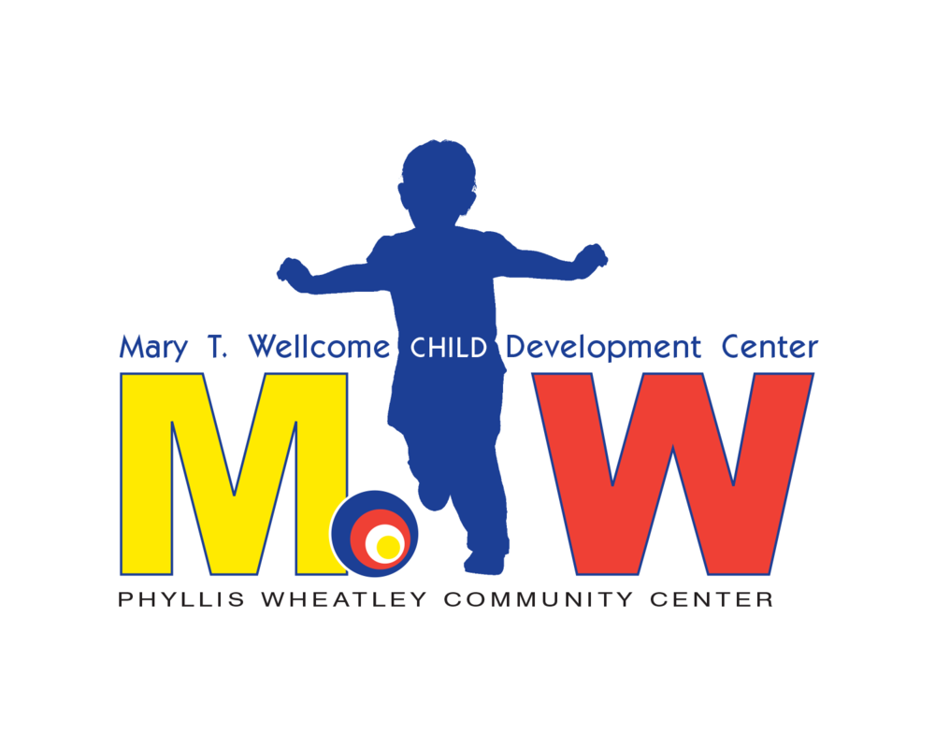

**Mary T Wellcome Child Development Center**

**Parent Manual**

**2019**

Hours of Operation: 6:30 am-5:30 pm

Monday-Friday

Revised 1/24/19

by Jessica Nordman

Assistant Director

**About Mary T Wellcome Child Development Center**

Founded in 1924 as a settlement house, Phyllis Wheatley Community Center (PWCC) was the first social service organization in the Twin Cities dedicated to serving African-Americans. Since 1929, PWCC has supported a child development center, daycare center and/or a nursery school. However, the program focus has changed with the needs of the community.

Mary T. Wellcome (MTW) Child Development Center is a licensed, non-profit child care center. MTW staff care for toddlers and preschoolers from 16 months to kindergarten (five years of age). MTW provides a healthy, safe, happy and constructive environment for children of different backgrounds. We gladly serve all children who meet our admission requirements.

**Licensure and Insurance**

MTW is by the Minnesota Department of Human Services. Our child care license is given on an annual basis, January through December. MTW complies with all aspects of the licensing rules and regulations, both state and federal. In addition, all Phyllis Wheatley activities, including MTW, have up to one million dollars of insurance coverage including personal injury and general liability.

**Operation**

Mary T Wellcome Child Development Center is open year-round, Monday through Friday, apart from holidays and two to three staff training days. Daily hours of operation are 6:30 am to 5:30 pm, except for possible weather emergency days. Parents receive a separate calendar indicating planned closures.

Parents are required to drop off their child by 930 am daily. If your child has a doctor’s appointment, you must notify your child’s teacher prior to the appointment and bring in a slip from your physician stating that your child had an appointment. Children with doctor’s appointments can be dropped off as late as 11:00 am.

*Classrooms*

Mary T. Wellcome has 3 classrooms:

Angelfish (Toddlers) ages 16 months to 2 ½ years

Starfish (Preschool) ages 2 ½ to 4 years

Dolphins (Prekindergarten) ages 4 to 5 years

**Program Goals**

The program goals for Mary T Wellcome Child Development Center are:

1. To provide cognitive, physical, emotional and social development to all children.
2. To provide a structured, literacy-rich environment that encourages and stimulates appropriate development in the following areas: cognitive, fine and gross motor, language, pre-reading, pre-math, science, language, social and emotional, and literacy skills.
3. To implement enjoyable learning experiences for young children 16 months through five years of age. This includes:

* Age appropriate teacher/child interactions and activities
* Parent conferences on the child’s developmental progress and
* Referrals for specific special needs of the individual child.

###### *Our Vision:* Together, we will ensure that every child has an equal opportunity to succeed in school and life.

###### *Our Mission:* Working closely with parents and communities, we ensure that children within the most isolated families are born healthy, stay healthy and are prepared for school.

**Rates**

Child care rates at MTW are as follows:

Toddlers: $275/week Preschoolers: $245/week

MTW offers a sliding fee scale based on family size and income to defray these expenses. The remainder of the cost is funded by the United Way and other foundation grants and donations contributed to the center. Payments through the Child Care Assistance Program (CCAP) and Pathway I Scholarships are also accepted for those who qualify. You may check with the Director or Assistant Director about other funding sources.

**Admission**

Any child between the ages of 16 months and five years is eligible for admission to MTW. The center is licensed to serve 54 children in a group child care setting. No child or parent seeking enrollment will be discriminated against based on race, gender, religion, color, creed, national origin, sexual orientation or source of payment for child care.

*Enrollment Conference*

When you choose to enroll at Mary T Wellcome Child Development Center, a pre-enrollment conference will be scheduled. At this conference, the program policies and services will be outlined for you. You will tour the program and meet the staff as well as discuss your child’s individual needs, which will be addressed by MTW’s curriculum. In addition, the policy regarding mandated reporting will be explained to you.

*Immunization Record and Health Care Summary*

Before a child is admitted, we must have a current immunization record and within 30 days of admission, the Center must obtain a report of a current physical examination on the child which is signed by the child’s medical provider.

*Child Abuse & Neglect*

*All program staff as well as volunteers are trained mandated reporters and are required by law to report cases of suspected child abuse and neglect. Upon enrollment in Way to Grow programming, families are notified of this law and our procedures for mandated reporting. If a report is made against a staff member, MTW’s internal review process will commence. The internal review policy is available for parents upon request.*

*Emergency Card*

Please keep your Emergency Cards updated every 6 months or as needed. Also, make sure that MTW is advised of current home, cellular, work and/or school telephone numbers.

*Permission Slips, Transportation, and Field Trips*

Each parent will be asked to complete a permission slip before any research, experiments, public relations, photo or video activity takes place. This form will then be placed in the child’s file. Children will occasionally go on outings to museums, apple orchard, local parks, etc. according to their weekly lesson plan. Parents will be informed ahead of time and will be asked to complete and sign a field trip slip for all program field trips. All children will be transported in federally approved safety restraints in accordance with Minnesota State law. Parents are welcome to join their child on field trips at any time.

*Adjustment*

Children beginning a new child care program may take some time adapting to their new surroundings and teachers. It is not uncommon for children to display behaviors such as crying, withdrawal, and shyness when entering a new program. This may take a couple of weeks to subside. Please be patient with your child and the new program as he/she goes through this period. The staff will ensure that your child’s adjustment to the program is as comfortable as possible. You are welcome to call your child’s classroom teacher to check on them whenever you need to.

Angelfish Class: 612-977-3244

Starfish Class: 612-977-3255

Dolphin Class: 612-977-3260

**Attendance Policy**

A child learns best and makes the most social-emotional growth when they are in a consistent routine. At MTW, we want our students here every day when possible. If your child misses ten days in a row, they could lose their spot. If your family will be out of town or has another event when the child will not be attending, let the teachers know in advance when possible. If your child is ill, please inform the teacher. After three consecutive days missed for illness, a doctor’s note is required for your child to return to MTW.

*Daily Sign In and Out*

You must sign your children into and out of the program daily. Daily sign in sheets are in your child’s classroom. A teacher must be made aware of your child’s entrance to and departure from the program. Verbal contact with the Program’s staff will keep us all informed that your child has a smooth transition into our program. Communication in this manner will help us ensure your child’s whereabouts and overall safety. If for any reason you will be detained in picking up your child, you must notify the Center so that we may know when to expect you or you can alert us of your alternative adult who will pick up your child that day.

*Alternate Pickup*

It is required that all alternates for picking up your child must be listed on your child’s emergency card or personal data record. You must contact and let us know who will be picking your child up. They will be required to show picture identification.

A child will not be released to an unauthorized person. If any person who is incapacitated or suspected of abuse arrives to pick up a child, we will call 911.

*Late Fees*

Mary T. Welcome Child Development Center closes promptly at 5:30 p.m. each day. If your child is not picked up by closing time, a late fee will be charged at a rate of $1.00 per minute per child. For example, if you have two (2) children and are 30 minutes late, your late fee will be $60.00. You will be given a late fee form completed by the staff indicating what your late fee is. This form will be signed by both the staff and parent to verify the time. The late fee needs to be paid within two days.

*Failure to Pick Up*

If a child has not been picked up by 5:30, staff will attempt to reach the parent or emergency contact persons by phone. If neither can be reached, staff will remain at the center until 6:30 pm, and will continue to attempt to reach parents/guardians or emergency contacts. If no one can be reached, staff will call the police and follow their instructions. A note will be left on the door for the parent regarding the situation and a phone number to call. Under NO circumstances will staff transport a child. Because of this possible situation, it is imperative that you keep your contact information up to date and make sure that your emergency contacts will pick your child up if you cannot be reached.

*Custody Issues*

MTW staff will not be involved in custody disputes. If parents have custody issues, they must provide the center with a copy of any relevant court documents.

**Nap and Rest Policy**

As a full day child care center, we do have a nap time built into our schedule. Every child has their own cot and blanket (either provided by home or MTW) and is expected to rest quietly for at least 30 minutes during nap time. If, after 30 minutes, the child is awake, they will be permitted to do a quiet activity while the other children sleep.

**Health Care**

The program has a visiting public health nurse from the Minnesota Visiting Nurse Agency. They consult with the program staff regarding health issues relating to the children. As a health consultant, they make monthly visits and reviews the center’s policies on health care. They also assist the program with sanitation issues.

**Food Program**

Meals are provided at Mary T Wellcome for each child daily. Through CACFP, the State of Minnesota reimburses the center for all meals served to low income children. The children receive breakfast, a hot lunch and afternoon snack daily. The food program follows USDA guidelines for serving sizes and nutritious foods. Children between the ages of 16 and 24 months will receive whole milk with their meals and children over 24 months will receive 1% milk.

Here are a few menu examples:

Breakfast

* 1% milk, pears and waffles
* 1% milk, Cheerios and peaches

Lunch

* 1% milk, hamburger with bun, green beans and pineapple
* 1% milk, spaghetti and meat sauce, peas and applesauce

This facility is operated in accordance with the US Department of Agriculture Policy which does not permit discrimination because of race, color, sex, age disability, religion, national origin or political beliefs. Any person who believes the he or she has been discriminated against in any USDA related activity should write immediately to: USDA, Director, Office of Civil Rights, 1400 Independence Avenue SW, Washington, DC 20250, or call (800) 795-3272 (voice) or (202) 720-6382 (TTY).

## Exclusion of Sick Children

If your child is ill, please do not send him/her to Way to Grow programming. Notify your child’s teacher that he/she will not be attending. Children are not allowed to attend programming if they exhibit any of the following symptoms or illnesses:

* Fever - If over 101 degrees orally, or accompanied by other symptoms such as behavior change, diarrhea, undiagnosed rash or vomiting
* Respiratory symptoms—Wheezing that occurs suddenly and is unexplained, severe congestion, uncontrolled coughing
* Signs/Symptoms of severe illness (unusual fatigue, irritability, persistent crying, difficulty breathing, etc.)
* Vomiting—If occurs more than once or is accompanied by other symptoms such as abdominal pain, behavior change, diarrhea or fever
* Uncontrolled diarrhea
* Mouth sores with drooling
* Rash—If cause of rash is unknown
* Eye drainage
* Unusual skin color
* Bacterial Infection (includes strep, ear infection, and impetigo)
* Contagious illness (such as chicken pox, scabies, ring worm, or other reportable diseases)
* Head Lice—presence of lice or lice eggs (“nits”)

***Children must be free from these symptoms for at least 24 hours before returning to Way to Grow, and any contagious illness should be cleared by a doctor.***

Parents/Families must notify the teacher if their child contracts a contagious disease as soon as diagnosed. When a contagious disease occurs, the preschool teachers will notify families in writing, including cause and symptoms.

If a child exhibits any of these illnesses while in the program, the child will be separated from the group and the parent/family will be called to come and pick up the child. If a parent or family cannot be reached, the emergency contact will be called. Staff will continue to assess the child’s condition. Families are required to pick up their child within one hour of the phone call. If the staff feels that your child’s condition warrants medical attention, the child’s source of healthcare, or 911 will be called.

## Medications

Mary T Wellcome staff will administer prescription medication during program hours only if a current Medication Permission Form is on file in your child’s classroom. Medication sent without a permission form will not be administered to your child. Medication must be sent in the original prescription-labeled bottle. Your pharmacist will divide a prescription if you wish. Children are not allowed to have medication in their possession.

The staff may only dispense prescribed medications in the original container that bears the original label displaying legible information stating the following:

* Name of medication and child’s name
* Date of original issue
* Directions for use
* Prescription number and expiration date
* Name and address of licensed pharmacy issuing the medication
* Physician’s name
* Strength and quantity of medication to be given

**Behavior Guidance Policy**

Mary T. Wellcome’s behavior policy is based on communication and the use of appropriate language rather than action. We encourage each child to use acceptable behavior to get their needs met by providing them with positive role models. When a child misbehaves, we speak to the child at eye level, stressing what the action was that was unacceptable rather than make the child feel bad about himself or herself. We also redirect children to new areas of play and help them find a duplicate toy if this is where the problem lies.

*Managing Discipline*

Good management of a discipline situation should never leave the child feeling disliked or unwanted as a person. Behavior may be disapproved of, but never the child him/herself. Discipline should never be an attempt to “get even” with a child. Children are not “good” or “bad; they are learning. Simple explanations of the reasons why children must or must not behave in certain ways are more helpful than meaningless comments like: “It isn’t nice” or “That’s naughty.”

Guidance of children is more successful if the caregiver suggests behavior that is acceptable to take the place of the behavior which cannot be approved. Tell the child what he/she cannot do. For example, “Use your walking feet. We don’t run in the classroom.”

Give the child a choice if you are willing to accept his/her decision. For example, “Do you want to sit in this chair or this one?” When obedience is necessary, be clear and firm, but remain friendly. Discipline methods should have a connection with the misbehavior. For example:

* If a child continues to throw sand at others, he/she should be removed from the sandbox and given something else to do.
* If a child runs from the group on a walk, it may be necessary to leave him/her at school on walk days until he/she can accept rules about staying with the group.

*Persistent Unacceptable Behavior*

In cases where a child has consistent unacceptable behavior, a record of the child’ behavior and the staff’s response to that behavior will be recorded to assess the function of the behavior. The program’s directors will spend time in the classroom observing the child’s behavior and offer possible alternative ways to address it. If the unacceptable behavior continues, a conference will be set up with the staff involved, the child’s parents/guardians, the directors, and other relevant persons (special education professionals, etc.) to develop a plan of action to manage the unacceptable behavior and provide the necessary support for the child.

*Exclusionary Measures*

If all available steps have been taken and the unsafe behavior persists (i.e. violence toward staff and/or students, running away), MTW may remove the student from the center temporarily or permanently. This step would only be taken if absolutely necessary for the safety of staff and students. MTW would offer assistance finding alternative care for the student. MTW complies with all federal and state civil rights laws.

*Separation from the Group*

A child may only be separated from a group if less intrusive methods of discipline have been ineffective and the child’s behavior threatens the well-being of the child and other children.

A child who is separated from the group will remain in an area where he/she is still supervised and safe. They will return to the group as soon as their behavior is under control and no longer a threat to anyone in the classroom. If it becomes necessary to separate from the group, a separation report will be completed, and parents will be notified.

*Prohibited Forms of Discipline*

At no time shall any MTW staff member employ any of the following methods to deal with a child who is displaying unacceptable behavior.

* Corporal punishment: This includes, but is not limited to, rough handling, shoving, hair pulling, ear pulling, shaking, slapping kicking biting, pinching, hitting, and/or shaking.
* Emotional abuse:This includes, but is not limited to, name calling, ostracism, shaming, making derogatory remarks about the child of the child’s family and/or using language that threatens, humiliates or frightens the child.
  + Also prohibited are the withholding of food, light, warmth, clothing and/or medical care; the use of physical restraints other than physically holding a child when containment is necessary to protect the child or another from harm, and the use of mechanical restraints such as tying. The use of punishment for lapses in toilet habits is also expressly forbidden.

*Rules*

Approval encourages children to learn. They work hard when they see that adults are pleased with their efforts. Children want and need reasonable rules. They are not comfortable if they have more freedom that they are able to manage. Rules should be appropriate for the stage of the development of the child.

Most of the program rules apply to the following situations:

* A child is in danger of hurting him/herself or others
* A child is interfering with the rights of others
* A child is misusing property, materials, and/or equipment
* A child’s behavior is disturbing to the group

**Parent Grievance Policy**

If you have concerns or questions about your child or the program, they should first be addressed with the classroom teachers. Unresolved concerns will be referred to Director, with a meeting set up between all concerned parties. If the issue is still not resolved, the issue will go to the Executive Director of Phyllis Wheatley Community Center for further review.

If you would like to contact DHS Licensing directly with concerns, you can call 651-431-6500.

**Curriculum**

All classrooms at Marty T. Wellcome Child Development Center use the Creative Curriculum from Teaching Strategies. The preschool and pre-kindergarten classroom supplement the Creative Curriculum with the BBL (Building Language for Literacy) (BBL) form Scholastic, Inc. Creative Curriculum allows teachers to create plans to address the needs of the whole child, including language, literacy, numeracy, and social-emotional development.

Your child’s daily schedule and lesson plan is posted on the parent board in classrooms. Please take the time to look at this weekly to see what your child will be working on that week.

*Assessments*

MTW utilizes the following assessments.

1. Teaching Strategies Gold Assessment for all children
2. Individual Growth and Development Inventory (IGDI) for children 3 years and older
3. Dynamic Indicators of Basic Early Literacy Skills (DIBELS) for children 4 years and older.

**Parent Teacher Conferences**

Parent teacher conferences are held twice each year, once in the spring and once in the fall. It is important for you to attend your child’s conference so you can understand what your child is working on in the program. It will give the teacher an opportunity to discuss your child’s strengths and what they need to work on. It will also give you a chance to ask any questions or raise any concerns you may have about the classroom or your child.

As staff at MTW it is useful for us to know of any changes going on with your child that may affect their behavior. Please keep us informed of things which you child may be experiencing such as: home environment change, recent incidents, favorite activities, sleeping habits, eating habits, toilet habits, fears, new skill and interests, etc. If we know your child is going through a transition, this will help us understand why he/she may be afraid, tired or anxious. We can better meet the needs of your child by knowing what he/she is experiencing outside the classroom.

**Supplies**

Please provide your child with all the necessary supplies they need. If your child is in diapers, you need to supply an adequate supply of diapers, wipes and diaper rash cream as needed. The container of wipes and the cream need to be labeled with your child’s first and last name. All children need to have a change of clothes in case of an accident, spills, etc. Everything you bring to the program should be labeled with your child’s first and last name.

During the summer, your child needs to have tennis shoes for playing outside. The children have a hard time playing on the playground with flip flops/sandals because they get full of sand and can be slippery which can cause unnecessary accidents. You are welcome to bring sunscreen with a SPF of greater than 15 for your child to wear outside in the summer. This must be labeled with your child’s first and last name.

In the winter, your child should dress appropriately for the weather. They should have boots, hat, mittens, jackets and snow pants each day. We are required to take the children outside every day that the weather is not below zero degrees.

Due to Health Department regulations, only commercially prepared foods in their original container are permitted.

**Parent Participation**

At MTW, we want you to be involved in our program. It is important for you to attend events, trainings, etc. that the program offers. Parents are always welcome to visit their child’s classroom. You can visit throughout the day although we do request that you refrain from visiting during your child’s naptime. You are welcome to eat meals with your child, attend any field trips or just spend time with him/her in the classroom.

Each year we have a graduation program for our children entering kindergarten in the fall. It is very important for you to attend the graduation ceremony if your child is graduating. They have worked very hard for this and it is an important milestone for them.

If you wish to celebrate your child’s birthday at the center, please make arrangements with the child’s teacher. Remember, only commercially prepared cakes and treats can be served.

**Severe Weather Closure Policy**

A general rule of thumb is that if the Minneapolis Public Schools are closed due to inclement weather, MTW will also be closed. Please check online or local news channels to see if Minneapolis Public Schools is closed. Staff will also make efforts to text or email before 6 am on such days. If the program will be closing early, you will be contacted by your child’s teacher about the time we will be closing. You will be responsible to make sure your child is picked up by that closing time.

**Special Services**

Mary T Wellcome Child Development Center provides the following special services:

1. Vision and Hearing Screening: for all children three years old and above, once a year.
2. Minneapolis Public School Early Childhood Screening: required for all children entering kindergarten at Minneapolis Public Schools once a year.
3. 348-TOTS screening also provides more in-depth screening for children as requested.
4. Information, referrals and support for children and families.
5. On site Speech and Language, Physical and Occupational Therapy through the Courage Center as needed.
6. Social Services cases can have their child care paid for as part of an overall case plan. The county social worker, parent and child development coordinator work together to develop and implement a treatment plan for each individual child based on his/her strengths and needs.

Whenever possible, we will arrange for other professionals to come into the center and supplement the basic services provided by our staff. We brief them on our concerns and consult with them on their findings and recommendations. All services are free except for the therapists from Courage Center. Their fees are paid through your medical insurance. If an outside appointment is made, we will assist in arranging transportation if necessary and will accompany you to the appointment if desired.

**Referral for Services**

As a child care provider, we continually monitor the development of all children in our care through ongoing observation and recording. We want the best outcomes for all children. Child care providers are considered a primary referral source for early intervention under the federal IDEA special education law. We are required to refer a child in our program who has been identified as having developmental concerns or a risk factor that warrants referral as soon as possible, but in no case more than seven days after identification. While this is a mandate, we want to keep open communication with parents and caregivers about their children and any concerns we have before a referral is made. We can assist the parent with the referral or partner with them in the referral process. Parents are within their rights to refuse any suggested services.

**Emergency Plan**

Mary T Wellcome Child Development Center has an Emergency Plan on file and in use for any type of emergency. Copies of this plan are available for parents to view at any time. Contact the Director or Assistant Director if you would like to view the MTW Emergency Plan.

**Child Care Program Plan**

Mary T Wellcome Child Development Center has a Child Care Program Plan on file. Copies of this plan are available for parents to view at any time. Contact the Director or Assistant Director if you would like to view the MTW Child Care Program Plan.